**Harry T. Zarate September 22, 2023**

**Nathaniel Ranque Santiago IT1R15**

**THE TRIPLE MOON GODDESSES**

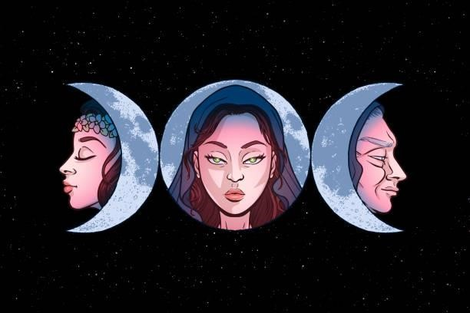• You may have seen the print picture of the 3 girls in the moon, each one of them have their own meaning, the center is the mother (SELENE), the right side is the crone (HECATE), and the left side is the maiden (ARTEMIS). What have things that made by the mother, crone, and the maiden of the moon of goddesses, the mother

(SELENE) represented the full moon, the mother symbolizes love, fertility, maturity, creativity, growth, and abundance. The crone (HECATE) represented by

the waning moon, the crone symbolize time, wisdom, culmination n, creativity, knowledge, courage. The last is the maiden (ARTEMIS) represented by the waxing moon, the maiden symbolize youth, purity, pleasure, beginnings, wildness, freedom, innocence. This 3 goddesses are a famous and significant character in many world legends, spiritual traditions, and belief systems.

The triple moon goddesses teach us that life is cycle that is full of growth, happiness, sad, knowledge and changes in our life cycle, so much like the appearance of the moon. The moon inspire us that we need to continue our life even we are in a hardest part, just live with grace and understanding, and acknowledge the beauty and wisdom in our beloved world.

Helen Berger writes about echoing of women, he allowed to identify with deity in a way that had not been possible since the advent of partriarchal religions. The Church of All Worlds is one of a neopagan organization which identifies the Triple Goddess as symbolizing a fertility cycle.

The triple moon goddess is a deity that rules one of the heavens, earth, and underworld. This goddess is known to be a symbol of the life cycles of a woman. The symbol of the triple moon goddess is always seen on the head of a priestess in certain tribes and religions. This symbol is one of the most powerful spiritual signs in the universe. It represents the most sacred aspect of our existence.

The triple moon goddess is popularly worshipped by females. It believed that the Christian and other orthodox religion worship the one true God, Other ancient religions worship the triple moon goddess as the one true god, who is a female.